EXAMINATION ONE (TOTAL MARKS 110)

Name: \_\_\_\_\_\_\_\_\_\_\_\_\_\_\_\_\_\_\_\_\_\_ Class: \_\_\_\_\_\_ Date: \_\_\_\_\_\_

SECTION A: MULTIPLE CHOICE QUESTIONS (total marks 40)

Answer all questions on the Multiple Choice Answer Sheet.

Question 1

Which of the following cells is a prokaryote?

|  |  |  |
| --- | --- | --- |
| A  C:\Users\K\Documents\Editing\Pearson\Heinemann Science\Editing\Edited\EDITED REDOWNLOADED FOR RESTYLING\JPEGs\HB12_5e_24_01_01Q.jpg  Source: © micro\_photo/Fotolia |  | B  C:\Users\K\Documents\Editing\Pearson\Heinemann Science\Editing\Edited\EDITED REDOWNLOADED FOR RESTYLING\JPEGs\HB12_5e_24_01_02Q.jpg  Source: © Lebendkulturen.de/Shutterstock |
|  |  |  |
| C  C:\Users\K\Documents\Editing\Pearson\Heinemann Science\Editing\Edited\EDITED REDOWNLOADED FOR RESTYLING\JPEGs\HB12_5e_24_01_03Q.jpg  Source: © jarun011/Fotolia |  | D  C:\Users\K\Documents\Editing\Pearson\Heinemann Science\Editing\Edited\EDITED REDOWNLOADED FOR RESTYLING\JPEGs\HB12_5e_24_01_04Q.jpg  Source: © Media - Biology/Getty Images |

Use the following information to answer questions 2 and 3.

Aquaporins are transmembrane proteins. They have domains on both the external and internal surfaces. Aquaporins allow water to move rapidly between the tissue fluid and the cytosol. They are very important in tissues such as the kidneys. Movement of water through the aquaporins is a passive process.

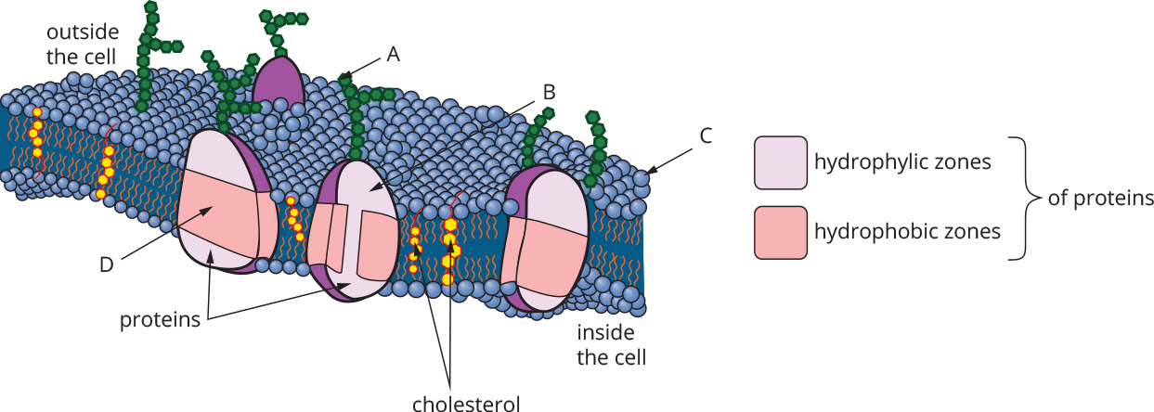

Question 2

In the diagram, the structure that is most likely to be an aquaporin is

1. Structure A.
2. Structure B.
3. Structure C.
4. Structure D.

Question 3

Aquaporins allow rapid movement of water into and out of cells. Small, soluble but uncharged molecules can pass through the pore with water. Aquaporins do not permit the movement of hydrophobic or charged molecules through their pore. Movement through the aquaporin is passive. It would be true to say of aquaporins that

1. they would permit the flow of sodium ions.
2. oestrogen would pass into the cytosol through them.
3. water would move through the pore from a concentrated solution to a dilute solution.
4. urea (CH4N2O) would be able to pass through the pore.

Question 4

Adrenalin is a hormone produced by the adrenal glands. Which of the following best describes the pathway of the adrenalin from production to release?

1. ribosomes, endoplasmic reticulum, transport vesicles, cell membrane
2. endoplasmic reticulum, lysosomes, Golgi apparatus, transport vesicles, cell membrane
3. endoplasmic reticulum, Golgi apparatus, smooth ER, transport vesicles, cell membrane
4. ribosomes, endoplasmic reticulum, transport vesicles, Golgi apparatus, transport vesicles, cell membrane

Question 5

The formation of compartments within the cell by membranes

1. is common to both eukaryotic and prokaryotic cells.
2. allows the cell to create microenvironments within the cell.
3. makes the cell wall continuous with some of the cell organelles.
4. is evidence for the endosymbiosis of mitochondria.

Question 6

The major factor that determines whether entry to the cell by a substance will be by endocytosis is

1. the size of the molecules being moved across the membrane.
2. the polarity of the substance.
3. the water solubility of the substance.
4. the concentration gradient of the substance between the inside and outside of the cell.

Question 7

Testosterone is the male sex hormone. The organelle most important in its synthesis is the

1. ribosome.
2. rough endoplasmic reticulum.
3. smooth endoplasmic reticulum.
4. Golgi complex.

Question 8

The unit within the nucleus that consists of histones and DNA is the

1. ribosome.
2. histosome.
3. centrosome.
4. nucleosome.

Question 9

A feature of many proteins is that they must undergo post-translational modification. An example of such modification is

1. the removal of introns.
2. alternative splicing of RNA to make protein variants.
3. the folding of a protein moderated by a chaperone protein.
4. the joining together of amino acids by the ribosomes in a hydrolysis reaction.

Question 10

Proteomics is

1. a branch of genomics.
2. the study of the proteins produced by a particular cell and how those proteins interact with each other.
3. the process of demonstrating that each gene produces one protein.
4. the study of how genes produce proteins.

**Use the following information to answer questions 11 and 12.**

The image below shows the molecular structure of haemoglobin.

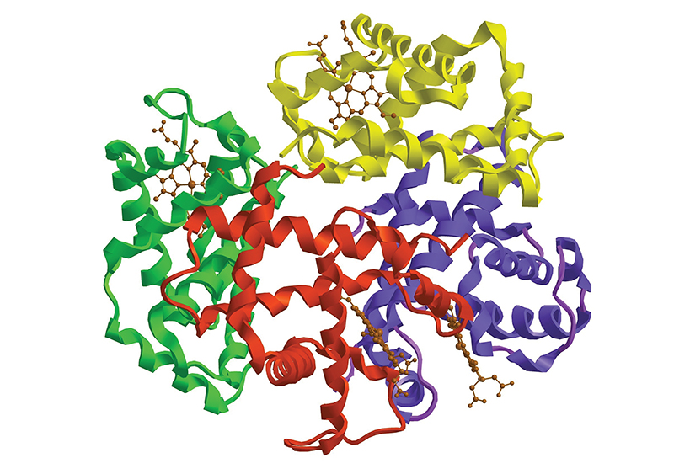

Source: © Raimundo79/Shutterstock

Question 11

The most common protein structures present in the haemoglobin are

1. alpha helices.
2. beta pleated sheets.
3. random coils.
4. haem molecules.

Question 12

Haemoglobin is a

1. primary protein structure.
2. secondary protein structure.
3. tertiary protein structure.
4. quaternary protein structure.

Question 13

A section of DNA has the sequence TTA GGC ACA GAA. As a result of transcription the mRNA formed would be

1. AAT CCG TGT CTT.
2. GGC TTA CAC TCC.
3. AAU CCG UGU CUU.
4. GGC UUA CAC UCC.

Question 14

Consider the structures shown below.

|  |  |  |
| --- | --- | --- |
| **Structure A** | **Structure B** | **Structure D** |
| C:\Users\K\Documents\Editing\Pearson\Heinemann Science\Editing\Edited\EDITED REDOWNLOADED FOR RESTYLING\JPEGs\HB12_5e_24_01_07Q.jpg | C:\Users\K\Documents\Editing\Pearson\Heinemann Science\Editing\Edited\EDITED REDOWNLOADED FOR RESTYLING\JPEGs\HB12_5e_24_01_08Q.jpg | C:\Users\K\Documents\Editing\Pearson\Heinemann Science\Editing\Edited\EDITED REDOWNLOADED FOR RESTYLING\JPEGs\HB12_5e_24_01_09Q.jpg  Source: © molekuul/123RF |
|  |  |  |
|  | **Structure C** |  |

The structures formed from only one molecule of nucleic acid are

1. structures B and C.
2. structures A and D.
3. structures A and C.
4. structures B and D.

Question 15

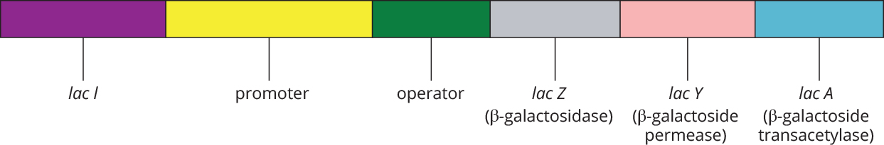

In the *lac* operon shown,

1. *lac Z* is a regulatory gene.
2. *lac l* is inducible.
3. *lac A* is expressed constitutively.
4. *lac Y* is a structural gene.

Question 16

Gene regulatory proteins work by

1. binding to ribosomes to activate them.
2. binding to the start codon to start translation at the ribosome.
3. affecting the speed at which DNA polymerase catalyses transcription.
4. binding to the promoter, thereby allowing or inhibiting RNA polymerase from transcribing the structural genes.

Question 17

An example of a biochemical pathway is shown below. This pathway produces a brown pigment in the eyes of *Drosophila*.

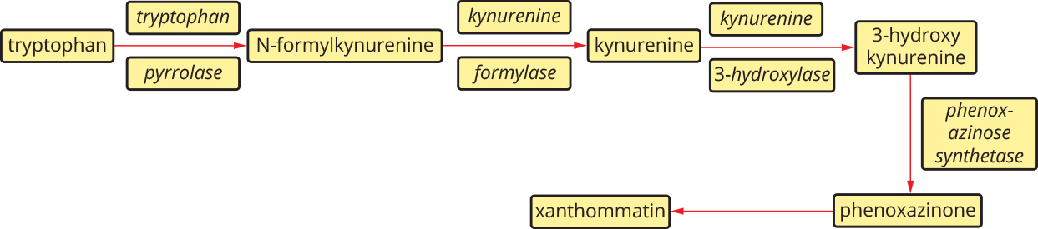

A mutation in the gene coding for kynurenine formylase will result in:

1. an accumulation of N-formylkynurenine and kynureine but no production of phenoxazinone.
2. an accumulation of N-formylkynurenine and phenoxazinone but no production of xanthommatin.
3. an accumulation of N-formylkynurenine and no production of kynurenine or any other product.
4. an accumulation of kynurenine but no production of N-formylkynurenine.

Question 18

During photosynthesis and respiration, co-enzymes are involved in carrying protons, electrons and energy between the different stages. It is true to say that

1. during the Krebs cycle, NADP+ is loaded to become NADPH.
2. NAD+ is produced during the reactions of the electron transport chain in the chloroplast.
3. the Calvin cycle uses energy released by the breakdown of ATP along with protons carried by NADPH to build glucose.
4. both mitochondria and chloroplasts have electron transport chains, during which ATP is formed to provide the energy used in the later catabolic reactions occurring in the organelle.

Question 19

Mitochondria and chloroplasts have a number of features in common. Which of the following characteristics is *not* common to both?

1. They are able to synthesise some of their own proteins.
2. They are descendants of once free-living organisms.
3. They use an electron transport chain to generate ATP.
4. The reactions in them are ultimately catabolic.

Use the following information to answer questions 20 and 21.

An area of land once used as a chemical factory was to be rehabilitated and revegetated, but the people working to achieve this were having trouble getting plants to grow. Investigations into the chemicals contaminating the soil suggested four possible culprits for the problems. The investigators hypothesised that one or more of these chemicals were affecting the plants’ ability to photosynthesise.

A series of experiments were performed where plants were exposed to each of the chemicals separately. All the experiments were carried out under bright light. The production of oxygen by the plants was monitored throughout the experiments. The plants’ oxygen production without any chemicals is shown below.

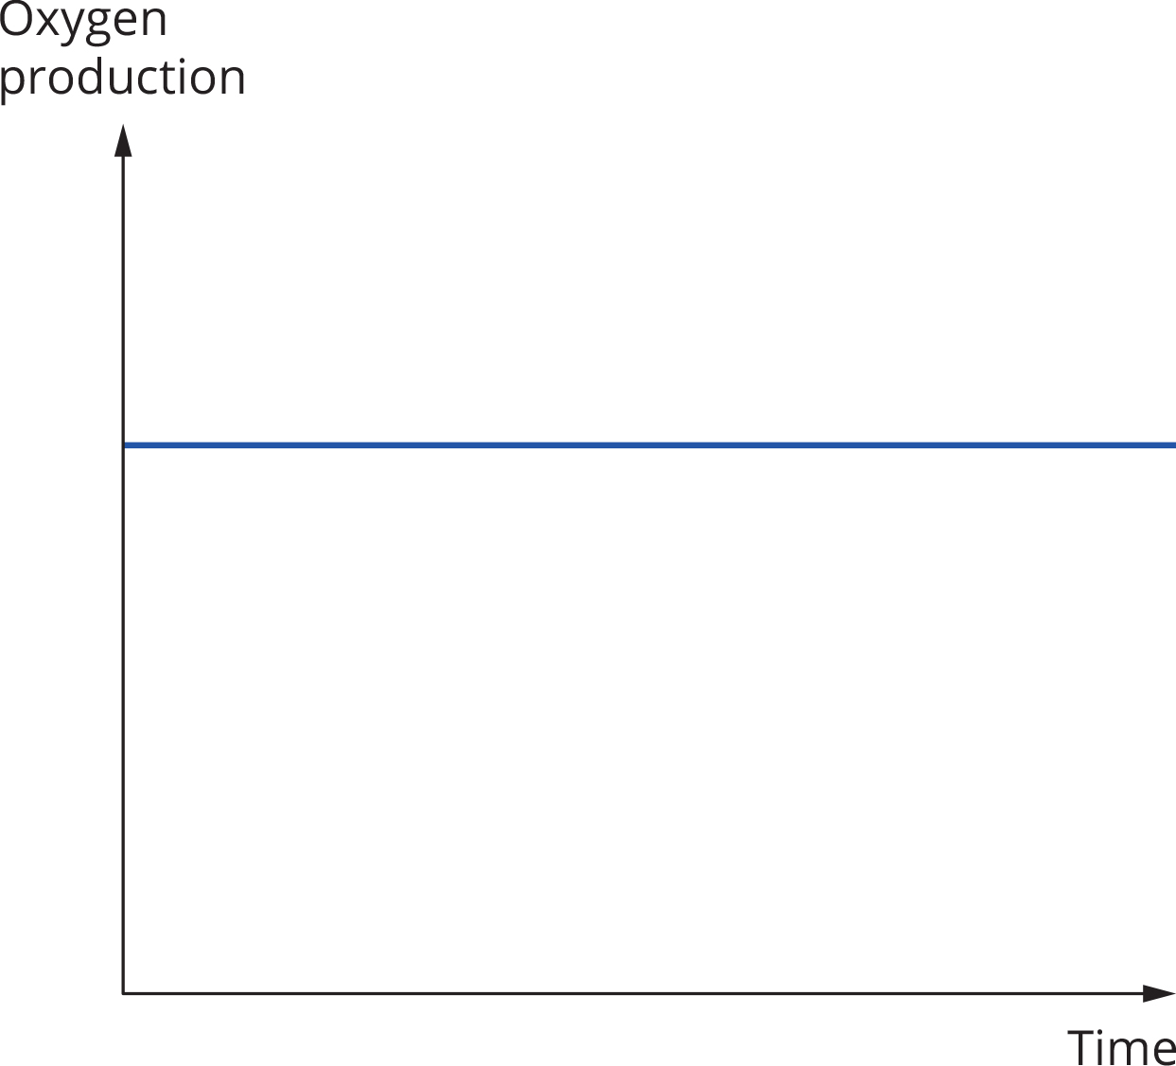

The results of the effect of the chemicals upon the plants’ oxygen production were graphed, as shown.

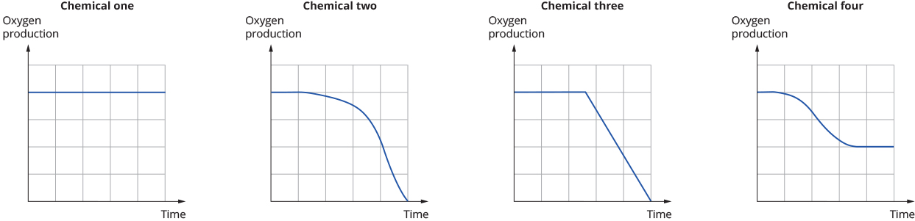

Question 20

The results of the experiment indicate that photosynthesis is impaired by

1. chemical one.
2. chemicals two and three.
3. chemicals two, three and four.
4. chemicals one, two, three and four.

Question 21

The aspect of photosynthesis that is most likely impaired is

1. the electron transport chain in the stroma of the chloroplast.
2. the Calvin cycle.
3. the acceptance of hydrogen ions by NAD.
4. the utilisation of light energy in the thylakoid.

Question 22

During the Krebs cycle, which of the following is *not* produced?

1. ATP
2. NADPH
3. CO2
4. FADH2

Question 23

Examples of paracrine signalling include all of the following *except*

1. the action of insulin on liver cells.
2. the action of a neurotransmitter on a muscle.
3. the action of histamine on surrounding tissues.
4. the action of neurohormones on the pituitary gland.

Question 24

A signalling molecule that requires an extracellular receptor is most likely to be

1. hydrophobic.
2. protein based.
3. peptide based.
4. lipid based.

Question 25

The control of cell function is a multi-step process, shown in the diagram below.

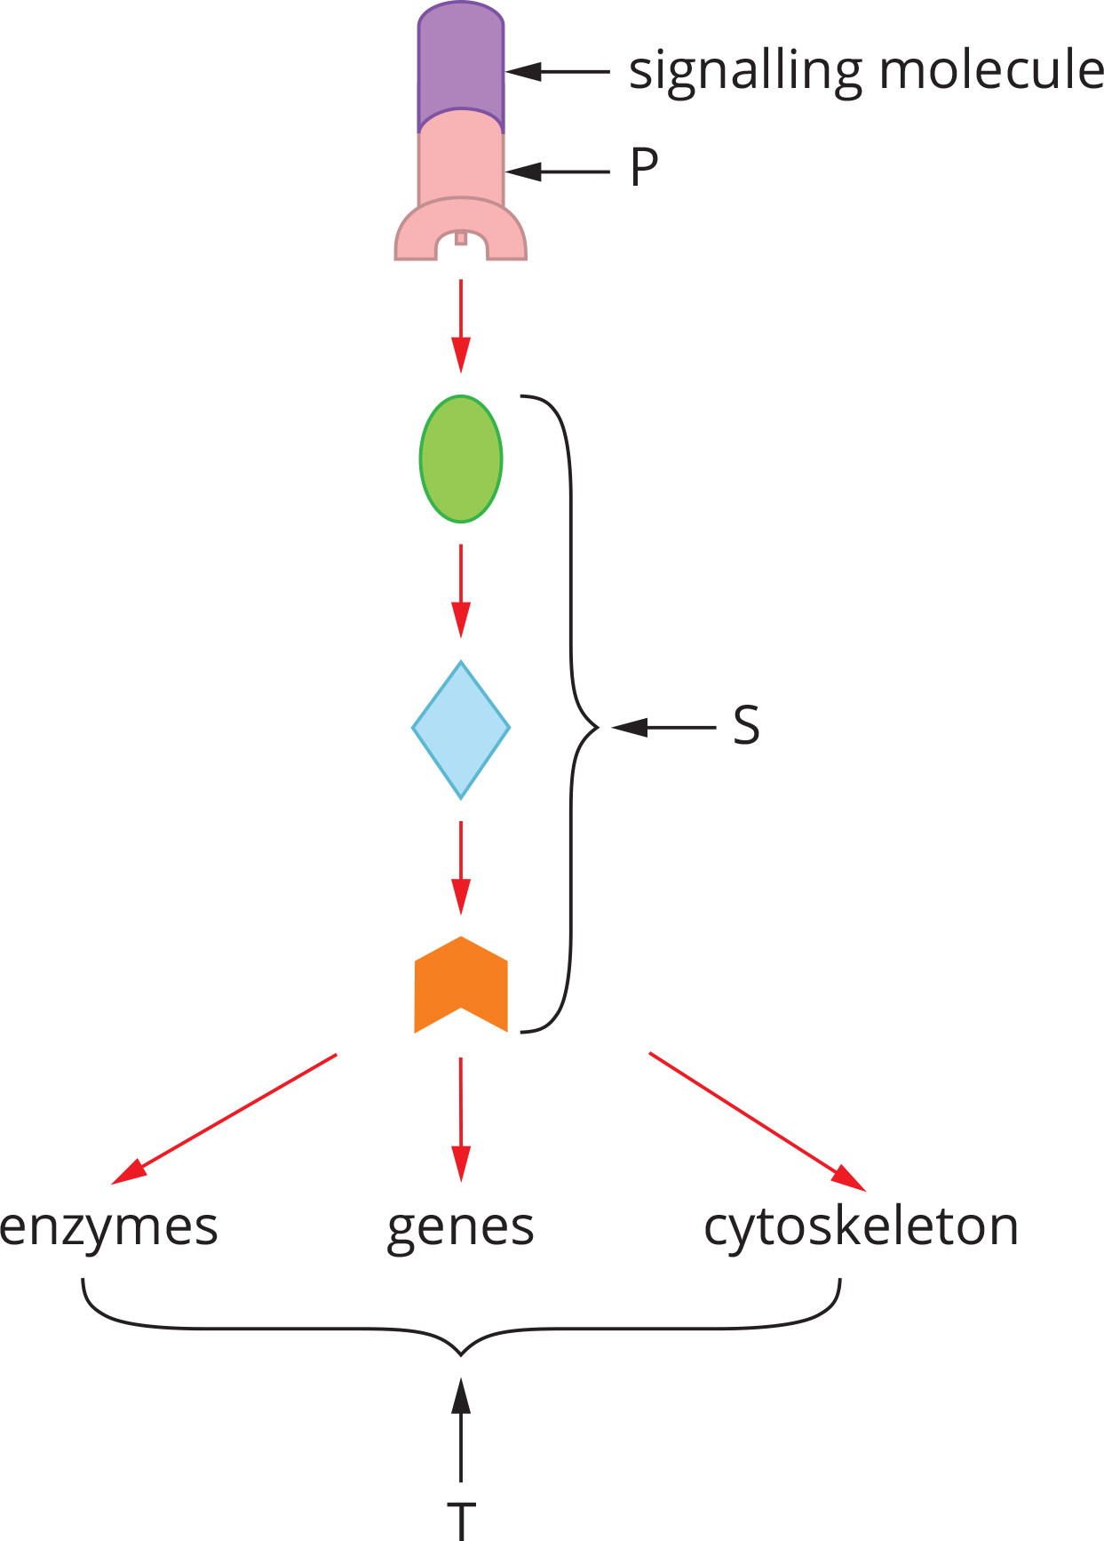

Which of the following statements about the control of cell functioning shown in the diagram is false?

1. If the signalling molecule is a protein, then P is usually a two-step process.
2. Stage S represents the transduction cascade.
3. If the signalling molecule is lipid based, then T must be a change in gene expression.
4. The site of P may be either extracellular or intracellular.

Question 26

Cancer results from at least two failures of normal cell behaviour. First, the cell undergoes a mutation, which causes an abnormally high rate of cell division. Then the abnormal cells fail to undergo apoptosis.

An important protein in this process is called p53. When active, p53 stops mitosis at an early checkpoint if DNA damage is detected, so DNA repair can occur. If repair is not possible, p53 initiates apoptosis.

Among its other functions, p53 affects the expression of the genes for two proteins important to apoptosis. These proteins are Bax, which promotes apoptosis, and Bcl, which inhibits it. The Bax protein forms a protein channel in the membrane of a mitochondrion through which cytochrome c can escape, initiating programmed cell death. The Bcl protein blocks that channel.

It would not be true to say of this process that in healthy cells

1. the gene coding for p53 is a regulatory gene.
2. p53 stops transcription of Bcl.
3. the pathway to apoptosis initiated by p53 is the intrinsic pathway.
4. when a cell has severe DNA damage, p53 would normally increase the transcription of Bax.

Question 27

The diagram below shows two cells. Cell A is a somatic cell from the tissues of a mouse. Cell B is a bacterial cell with which the mouse has been infected.

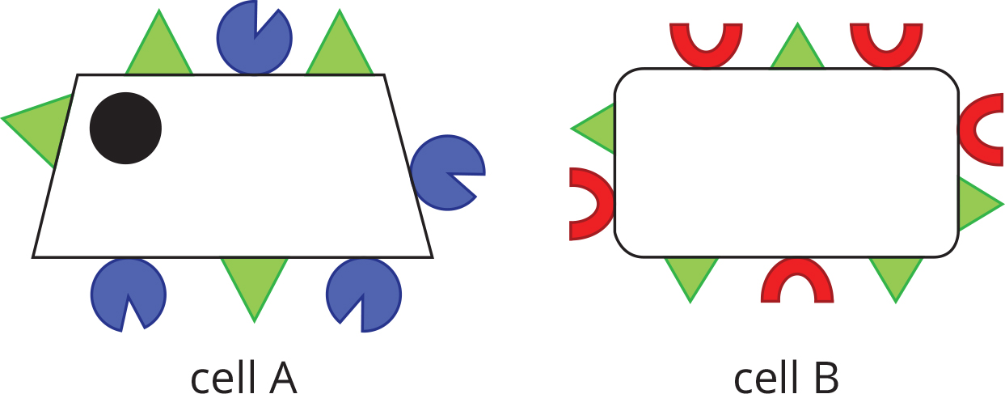

After the mouse’s recovery from the infection, it would be expected that large numbers of the following antibody would be found in the blood and tissues.

|  |  |  |  |
| --- | --- | --- | --- |
| A | B | C | D |
| C:\Users\K\Documents\Editing\Pearson\Heinemann Science\Editing\Edited\EDITED REDOWNLOADED FOR RESTYLING\JPEGs\HB12_5e_24_01_17Q.jpg | C:\Users\K\Documents\Editing\Pearson\Heinemann Science\Editing\Edited\EDITED REDOWNLOADED FOR RESTYLING\JPEGs\HB12_5e_24_01_18Q.jpg | C:\Users\K\Documents\Editing\Pearson\Heinemann Science\Editing\Edited\EDITED REDOWNLOADED FOR RESTYLING\JPEGs\HB12_5e_24_01_19Q.jpg | C:\Users\K\Documents\Editing\Pearson\Heinemann Science\Editing\Edited\EDITED REDOWNLOADED FOR RESTYLING\JPEGs\HB12_5e_24_01_20Q.jpg |

Question 28

While on camp, a student was scratched with a rusty nail. This resulted in the entry of pathogens, activating the student’s innate immune response. The innate response would not include

1. presentation of antigens to TH cells by dendritic cells.
2. activation of complement proteins.
3. phagocytosis by macrophages.
4. inflammation.

Question 29

Antigen-presenting cells

1. may be T cells.
2. do not produce cytokines.
3. may become plasma cells when mature.
4. are all lymphocytes.

Question 30

An ecologist was investigating a valley where a number of similar groups of animals lived. The scientist was unsure whether the group represented one species or a number of closely related, but separate, species. Observation of the animals showed that there were five, possibly separate, groups. It was noted that individuals in group 1 never mated with any of the other groups. Individuals in group 3 were seen to mate with members of both groups 2 and 4, but matings between 3 and 4 rarely produced viable offspring. Members of groups 4 and 5 were seen to mate frequently. Finally, groups 2 and 5 were never observed mating.

The number of species present in the valley is

1. two.
2. three.
3. four.
4. five.

Question 31

Reproductive isolation results in cessation of gene flow, which can lead to speciation. Isolation can be either pre-zygotic or post-zygotic. Which of the following is an example of a factor that results in post-zygotic isolation?

1. Drosophila ananassae and Drosophila pallidosa have different courtship behaviours.
2. Polar bears (Ursus maritimus) live in the Arctic, and brown bears (Ursus arctos) live in North America.
3. The bullfrog (Lithobates catesbeianus) and the leopard frog (Lithobates pipiens) produce offspring that do not survive to maturity.
4. In the butterfly species Heliconius melpomene and Heliconius cydno, the colour and pattern of the wings is crucial to choice of mate.

Question 32

The diagram below shows a mutation. Peptide chain (a) is the normal chain and peptide chain (b) is the mutated version.

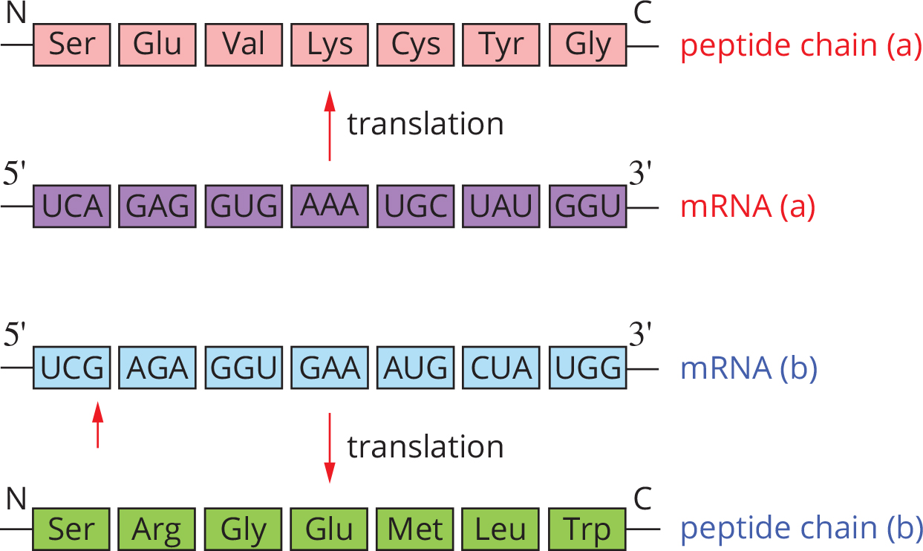

The mutation shown is

1. a point mutation.
2. a block mutation.
3. a silent mutation.
4. a frameshift mutation.

Question 33

Two pieces of evidence that support the theory that life existed on Earth 3000 million years ago are

1. fossilised prokaryotes and cyanobacteria in ancient rocks.
2. ancient fossils and radiocarbon dating.
3. the discovery of stromatolites and microfossils.
4. the studies of palaeontology and geology.

Question 34

In insects, two proteins are coded for by homeotic genes in the Hox family. These proteins, called bicoid and caudal, control the development of the body plan of the insect. Both proteins are regulatory in nature. In the fertilised egg, bicoid is high at the anterior (head) end, low in the centre (thorax) and absent at the posterior end (abdomen). At the same time, caudal concentrations are exactly the opposite.

Which of the following is not a reasonable hypothesis to explain how the body plan of an insect develops?

1. The ratio of bicoid to caudal regulates the development of the thorax.
2. Caudal suppresses genes needed for head development in the abdomen.
3. Bicoid acts as a transcription factor, which inhibits transcription of genes needed for development of the abdomen.
4. Bicoid must be in high concentration for a head to develop.

Question 35

The table below shows the differences between the DNA of a human and four other species of primate.

|  |  |
| --- | --- |
| Species tested against human DNA | Difference (%) |
| Human | 0.0 |
| Chimpanzee | 2.4 |
| Gibbon | 5.3 |
| Green monkey | 9.5 |
| Capuchin monkey | 15.8 |

The phylogenetic tree that best shows the relationships portrayed in the table is

|  |  |
| --- | --- |
| **A** | C:\Users\K\Documents\Editing\Pearson\Heinemann Science\Editing\Edited\EDITED REDOWNLOADED FOR RESTYLING\JPEGs\HB12_5e_24_01_22Q.jpg |
| **B** | C:\Users\K\Documents\Editing\Pearson\Heinemann Science\Editing\Edited\EDITED REDOWNLOADED FOR RESTYLING\JPEGs\HB12_5e_24_01_23Q.jpg |
| **C** | C:\Users\K\Documents\Editing\Pearson\Heinemann Science\Editing\Edited\EDITED REDOWNLOADED FOR RESTYLING\JPEGs\HB12_5e_24_01_24Q.jpg |
| **D** | C:\Users\K\Documents\Editing\Pearson\Heinemann Science\Editing\Edited\EDITED REDOWNLOADED FOR RESTYLING\JPEGs\HB12_5e_24_01_25Q.jpg |

Use the following information to answer questions 36 and 37.

In the process of genetic engineering, molecular tools are used. Many of these tools came from bacteria and viruses. These tools include restriction enzymes, reverse transcriptase, taq polymerase and plasmids.

Question 36

Reverse transcriptase is used to make cDNA. The cDNA is used to make copies of genes for insertion into plasmids, for the engineering of bacteria to make human proteins.

cDNA is ideal for this application because it lacks

1. a promoter sequence.
2. any introns.
3. a start triplet.
4. a stop codon.

Question 37

Of taq polymerase it is *not* true to say that

1. it is used during the polymerase chain reaction to copy DNA.
2. it is useful because it maintains activity at 90°C.
3. it was derived from the bacterium Thermus aquaticus.
4. its function in the original cell is to protect against invasion by viral DNA.

Question 38

Four hominin skulls are represented in the diagrams below. Examine the diagrams carefully.

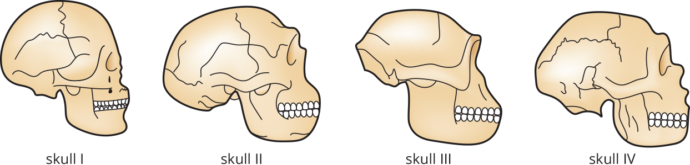

The correct arrangement of the skulls in order from oldest to youngest would be

1. Skull II, Skull IV, Skull I, Skull III.
2. Skull III, Skull II, Skull IV, Skull I.
3. Skull I, Skull IV, Skull II, Skull III.
4. Skull III, Skull IV, Skull II, Skull I.

Question 39

The Out of Africa model of human spread maintains that

1. modern humans evolved in Africa, then migrated out of Africa and spread across the world.
2. modern humans evolved in different regions of the world simultaneously.
3. humans evolved in various regions of the world and then spread out.
4. modern humans are direct ancestors of the African species.

Question 40

It is true to say that examples of cultural evolution

1. are confined to Homo sapiens.
2. include bipedal locomotion and increase in cranial capacity, seen in hominins.
3. include developments in art and ritual in Homo sapiens.
4. cannot occur without the use of language.

SECTION B: SHORT ANSWER QUESTIONS (Total marks 70)

Answer all questions in the spaces provided.

Question 1 (Total marks 7)

Abscisic acid (ABA) is an important plant hormone. In some species of plants it plays a major role in activating mechanisms that assisting the plant in dealing with water stress. Declining water potentials in the root trigger the production of abscisic acid.

a Initially, the abscisic acid is transported to the leaves, where it triggers the closing of stomata. How would the ABA reach the stomata? 1 mark

b Research into the action of ABA has also shown that it plays a role in gene regulation in some plants, notably Arabidopsis, where it triggers the production of proteins that help the plant to cope with water stress.

The diagram below shows one suggested model of how the group of proteins that help to protect Arabidopsis are produced by the cell.

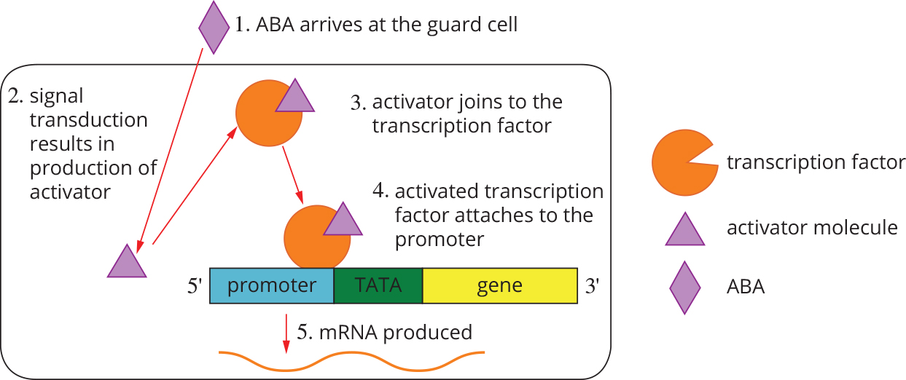

1. What is a transcription factor? 1 mark
2. The diagram stops at step 5, the production of mRNA. Where does the next stage of protein production take place? 1 mark
3. Describe fully the process that produces the protein. 4 marks

Question 2 (Total marks 6)

Tadpoles of the Dwarf American Toad (Bufo americanus charlesmithi) are often found in shallow pools. These pools are subject to rapid temperature increases on hot days; as the water heats, the concentration of dissolved gases falls. This results in the tadpoles suffering from oxygen stress. Also found in the pools are algae of the genusChlorogonium. As temperatures in the pools increase, these algae are also affected. Reduced gas concentrations limit their ability to photosynthesise.

a Which stage or stages of photosynthesis will be limited by the rising temperatures? Explain. 2 marks

b Chlorogonium have flagella that allow them to move. In the hot pools, the algae use their flagella to hover close the skin of the tadpoles. This close relationship benefits both organisms. Explain how. 2 marks

c An experiment was performed using tadpoles and algae. Two pools were constructed. Both contained tadpoles but only one had algae. In the pool with only tadpoles, at 39.5°C the tadpoles showed poor responses to the stimuli and by the time the temperature reached 40°C the tadpoles were either dead or dying. In the pool with tadpoles and algae, at a temperature of 40°C the tadpoles were still able to respond normally to stimuli. These tadpoles continued to behave normally until the temperature reached 44°C, at which stage these tadpoles also died. Suggest why there was a difference between the two pools. 2 marks

Question 3 (Total marks 12)

Influenza is a disease caused by a group of RNA viruses. There are three types: A, B and C. Types B and C mutate slowly and do not spread easily, and so are not a serious concern to medical authorities. Type A viruses have caused several major pandemics.

**a** What is a pandemic and how is it different from an epidemic? 2 marks

Influenza viruses are named according to the variants of two proteins that they possess: hemagglutinin and neuraminidase. Hemagglutinin is used by the virus to attach to a cell so that it can infect it, and neuraminidase is an enzyme that the virus uses to escape from the cell.

**b** Relenza® is an anti-viral medication designed to inhibit neuraminidase.

1. To which group of biologically active molecules does neuraminidase belong? 1 mark
2. Explain how Relenza® reduces the duration of influenza. 2 marks
3. Why must Relenza® be administered early in the disease, to have any effect? 1 mark

**c** The structure of the head of the most common of the neuraminidase variants is shown below.

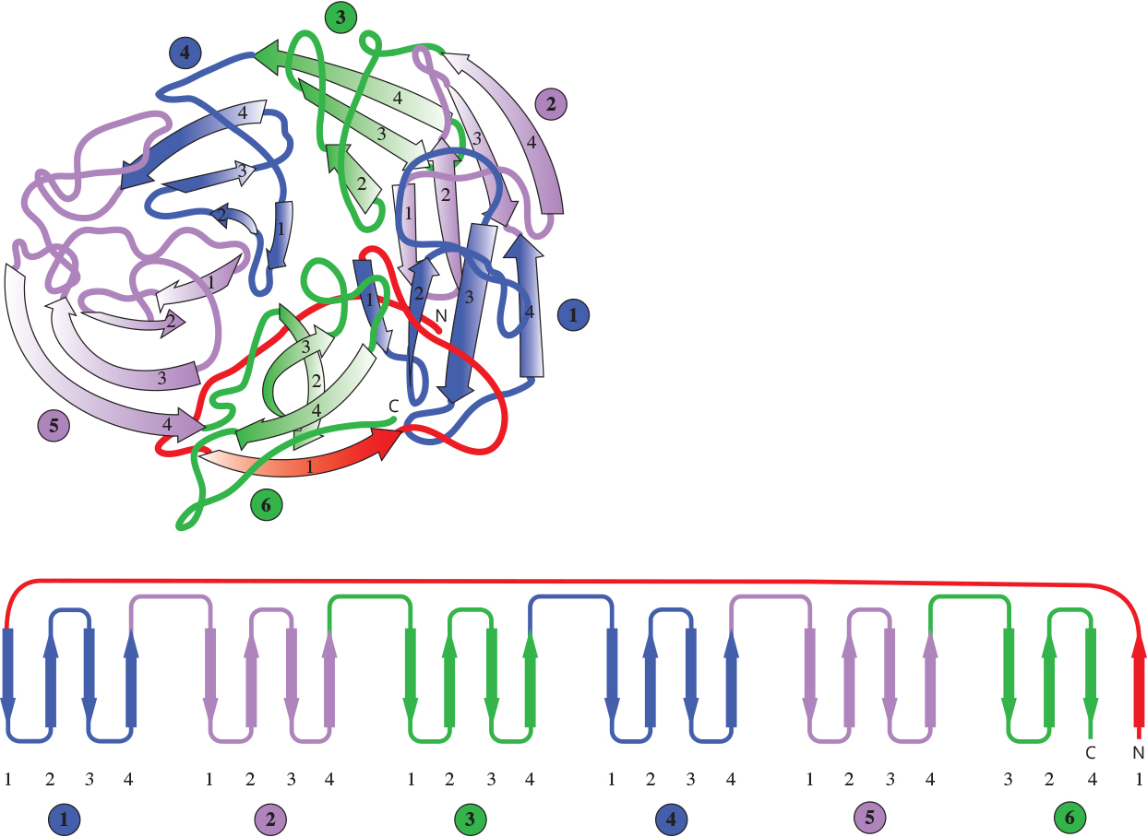

1. This section of the enzyme consists of six secondary structures. What are these secondary structures? 1 mark
2. Neuraminidase is made from 466 amino acids. What is the minimum number of bases that could make up the gene that codes for it? 1 mark
3. The first nine amino acids of neuraminidase are given below.

MET LEU PRO SER THR VAL GLN THR LEU

The table below shows the triplets for amino acids in the template strand of the DNA extracted from a cell infected with the influenza virus.

|  |  |  |  |  |  |  |  |
| --- | --- | --- | --- | --- | --- | --- | --- |
| Amino acid | LEU | GLN | MET | PRO | SER | THR | VAL |
| DNA sequences | AAT  AAC  GAA  GAG  GAT  GAC | GTT  GTC | TAC | GGA  GGG  GGT  GGC | AGA  AGG  AGT  AGC  TCA  TCG | TGA  TGG  TGT  TGC | CAA  CAG  CAT  CAC |

Using the information given, suggest a suitable nucleic acid sequence for the influenza virus. 2 marks

1. Is the sequence that you suggested in part **iii** likely to be the same nucleic acid sequence as that in the virus? Explain why or why not. 1 mark
2. Briefly describe the process by which the amino acids are joined to form the protein. 1 mark

Question 4 (Total marks 13)

In 2004 a new influenza strain in the H5N1 family of viruses arose in birds in Asia. ‘Bird Flu’ caused worldwide concern, as it became clear that the virus could move from birds to humans. Strict quarantine of anyone showing symptoms contained the disease, but there were still significant numbers of fatalities. Many of the fatalities occurred as a result of acute respiratory distress syndrome (ARDS). ARDS is severe damage to the lungs caused by excessive release of cytokines, which causes many lung cells to undergo apoptosis.

**a** The stimulation of large numbers of cytokine receptors in lung cells results in the triggering of apoptosis in otherwise healthy cells, by the extrinsic pathway.

1. Explain why lung cells are exposed to many cytokines during an influenza infection. 1 mark
2. Describe the extrinsic apoptotic pathway. 2 marks

**b** The table below shows the incidence of Bird Flu in humans and the number of fatalities up to December 2006.

|  |  |  |  |
| --- | --- | --- | --- |
| Country | Time frame | Number of  cases | Number of fatalities |
| Azerbaijan | Feb 06 – Mar 06 | 8 | 5 |
| Cambodia | Jan 05 – Mar 06 | 6 | 6 |
| China | Oct 05 – Apr 06 | 18 | 12 |
| Egypt | Mar 06 – Apr 06 | 12 | 4 |
| Indonesia | Jul 05 – Mar 06 | 32 | 24 |
| Iraq | Jan 06 – Jan 06 | 2 | 2 |
| Thailand | Jan 04 – Nov 05 | 22 | 14 |
| Turkey | Dec 05 – Jan 06 | 12 | 4 |
| Vietnam | Dec 03 – Nov 05 | 91 | 42 |

1. Where did Bird Flu originate? Use the data to justify your suggestion. 2 marks

The number of human cases of Bird Flu was fairly small, but worldwide precautions were taken to stop it spreading. Millions of chickens, ducks and geese were euthanased. Also, in all major airports, anyone coming from a country where Bird Flu had occurred was screened for a raised temperature, and if the result was positive the person was immediately quarantined.

1. Use the data in the table to explain why such stringent precautions against the spread of this disease were implemented. 1 mark
2. Following the outbreak there was a large research effort to create a successful vaccine, and people in affected areas were encouraged to be vaccinated. How does a large-scale vaccination program reduce the risk of a major outbreak of a communicable disease? 1 mark

**c** The table below shows the distribution of deaths due to Bird Flu, by age and sex.

Mortality of Bird Flu according to age and sex

|  |  |  |
| --- | --- | --- |
| Age group (years) | Deaths | |
| Male | Female |
| ˂ 5 | 13 | 8 |
| 5 ˂ 9 | 19 | 13 |
| 10 ˂ 19 | 18 | 31 |
| 20 ˂ 29 | 18 | 27 |
| 30 ˂ 39 | 17 | 16 |
| 40 ˂ 49 | 5 | 6 |
| 50+ | 6 | 5 |

1. Draw a graph of the data in the table. 3 marks

|  |  |  |  |  |  |  |  |  |  |  |  |  |  |  |  |  |  |  |  |  |  |  |  |  |
| --- | --- | --- | --- | --- | --- | --- | --- | --- | --- | --- | --- | --- | --- | --- | --- | --- | --- | --- | --- | --- | --- | --- | --- | --- |
|  |  |  |  |  |  |  |  |  |  |  |  |  |  |  |  |  |  |  |  |  |  |  |  |  |
|  |  |  |  |  |  |  |  |  |  |  |  |  |  |  |  |  |  |  |  |  |  |  |  |  |
|  |  |  |  |  |  |  |  |  |  |  |  |  |  |  |  |  |  |  |  |  |  |  |  |  |
|  |  |  |  |  |  |  |  |  |  |  |  |  |  |  |  |  |  |  |  |  |  |  |  |  |
|  |  |  |  |  |  |  |  |  |  |  |  |  |  |  |  |  |  |  |  |  |  |  |  |  |
|  |  |  |  |  |  |  |  |  |  |  |  |  |  |  |  |  |  |  |  |  |  |  |  |  |
|  |  |  |  |  |  |  |  |  |  |  |  |  |  |  |  |  |  |  |  |  |  |  |  |  |
|  |  |  |  |  |  |  |  |  |  |  |  |  |  |  |  |  |  |  |  |  |  |  |  |  |
|  |  |  |  |  |  |  |  |  |  |  |  |  |  |  |  |  |  |  |  |  |  |  |  |  |
|  |  |  |  |  |  |  |  |  |  |  |  |  |  |  |  |  |  |  |  |  |  |  |  |  |
|  |  |  |  |  |  |  |  |  |  |  |  |  |  |  |  |  |  |  |  |  |  |  |  |  |
|  |  |  |  |  |  |  |  |  |  |  |  |  |  |  |  |  |  |  |  |  |  |  |  |  |
|  |  |  |  |  |  |  |  |  |  |  |  |  |  |  |  |  |  |  |  |  |  |  |  |  |
|  |  |  |  |  |  |  |  |  |  |  |  |  |  |  |  |  |  |  |  |  |  |  |  |  |
|  |  |  |  |  |  |  |  |  |  |  |  |  |  |  |  |  |  |  |  |  |  |  |  |  |
|  |  |  |  |  |  |  |  |  |  |  |  |  |  |  |  |  |  |  |  |  |  |  |  |  |
|  |  |  |  |  |  |  |  |  |  |  |  |  |  |  |  |  |  |  |  |  |  |  |  |  |
|  |  |  |  |  |  |  |  |  |  |  |  |  |  |  |  |  |  |  |  |  |  |  |  |  |
|  |  |  |  |  |  |  |  |  |  |  |  |  |  |  |  |  |  |  |  |  |  |  |  |  |
|  |  |  |  |  |  |  |  |  |  |  |  |  |  |  |  |  |  |  |  |  |  |  |  |  |

1. The way the data is displayed is somewhat misleading. In what way is the data misleading? 1 mark
2. Explain whether the data suggests that either sex is more susceptible to Bird Flu. 1 mark
3. The data given is from a WHO (World Health Organization) report. WHO does not collect its own data. It relies on self-reporting from affected countries. Comment on the reliability of the data presented. 1 mark

Question 5 (Total marks 12)

Over a million people are stung by scorpions each year, and a significant number of fatalities occur. Scorpion venom is a neurotoxin. It attaches to the protein channels that allow Na+ ions to enter motor neurons. Currently anti-venoms are produced by injecting large mammals (often horses) with small amounts of the toxin. The blood serum is then collected and the antibodies purified. The major issue with this type of anti-venom is that it causes a serious allergic reaction in a significant number of individuals.

**a** Why would the anti-venom cause an allergic reaction? 1 mark

**b** Which group of antibodies are involved in the allergic reaction? 1 mark

**c** **i** Explain how the anti-venom created from the horse serum neutralises the scorpion venom. 2 marks

1. If the patient is subsequently bitten again, will they have immunity from the previous bite? Explain why or why not. 1 mark

**d** There have been reports of individuals who keep and work with venomous animals, especially snakes, who seem to have developed a tolerance to the venom of the animals with which they work. These people no longer needed to seek treatment when bitten. Suggest how this tolerance has developed. 2 marks

One area of research has shown considerable promise in creating anti-venoms that are much less likely to cause allergic reactions. Research into monoclonal antibodies aims to produce humanised antibodies that target the venom particles.

**e** Explain why humanised monoclonal antibodies are less likely to cause an immune response than antibodies derived from horses. 1 mark

The diagram below shows the shape of three toxins found in scorpion venom.



**f** **i** Draw and fully label an antibody that could be purified from a horse that has been induced to create antibodies. 3 marks

1. A scientist claims to have produced a bispecific antibody to the scorpion venom. How would this differ in structure from the horse antibodies? 1 mark

Question 6 (Total marks 5)

The Convention on International Trade in Endangered Species (CITES) is an international agreement designed to protect endangered species of flora and fauna. It has been law in Australia since 1976. Along with Federal and State agencies, including police and border protection, a number of scientific institutions such as the Australian Wildlife Forensic Service at Curtain University are working to enforce the laws that stop this trade. In order to establish that trade in a live animal or plant, or tissue, is illegal it must first be established that the disputed organism or material is actually one that is subject to the agreement. It is at this stage that the forensic services are called upon.

In Australia, most native species are protected. This means that any person wishing to keep native animals as pets or for breeding must be licensed and must keep detailed breeding records. Except for specialised breeding programs run under government control (mostly in zoos), animals may not be taken from the wild.

Most people involved with the breeding and care of native animals are well meaning and take good care of the animals, but there are some whose main aim is to exploit the animals. Some of Australia’s most endangered species bring huge prices on the animal black market. One rare species of black cockatoo can bring up to $30 000 per bird. Unscrupulous breeders sometimes sell birds illegally and then take another from the wild to replace the bird they sold. Their records appear to be in order as they have the correct number of birds. DNA technology has made this practice much more difficult, as it is now possible to determine whether young birds held in captivity could be the offspring of the adults known to be legally in the breeder’s possession.

One such suspicious breeder was investigated. The breeder’s records showed that he had a pair of adult red-tailed black cockatoos (Calyptorhynchus banksii), which he had been breeding for several years. Also in his possession were six young birds, which he claimed were the offspring of his breeding pair. Wildlife officers were suspicious because of the large number of young birds, which they felt were too many for one pair to have produced over the relevant period. Tissue samples were taken from all eight birds, and a DNA profile was generated for one particular locus. The profile is shown on the following page.

(Source: Australian Wildlife Forensic Services, Background info, http://www.wildlifeforensics.com.au/background\_info.html)

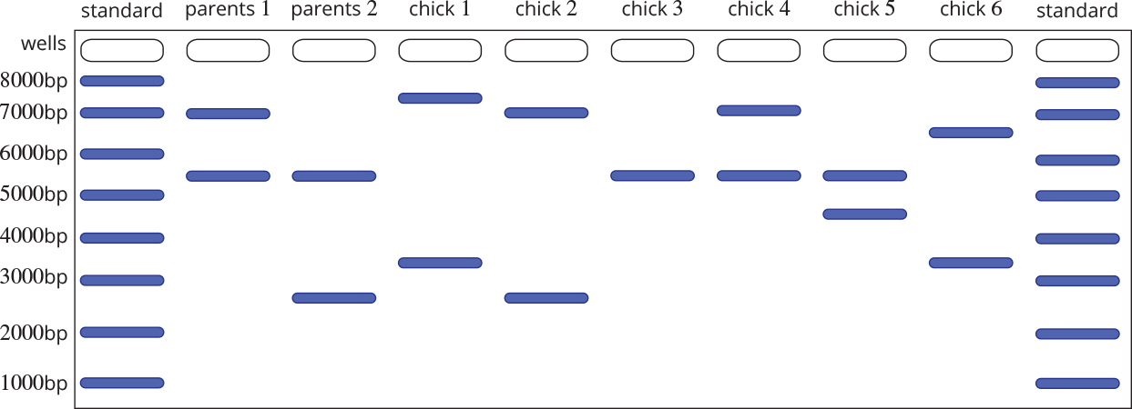

**a** Why does Chick 3 have only one band? 1 mark

**b** Explain which chicks, if any, are not the offspring of the two parent birds.

2 marks

**c** If a chick’s bands match the proposed parents, it does not mean with absolute certainty that the chick belongs to those parents. How would you increase your confidence that the assignment of parents is correct? 1 mark

**d** How long are the DNA fragments produced by Parent 1? 1 mark

Question 7 (Total marks 9)

Two types of light receptors are found in primate eyes: rods, which see in black, white and shades of grey and are effective even in low light intensities; and cones, which see colour but are only effective in high light levels.

The ability to see in colour varies across the primates. Colour vision in humans results from the interactions of three different light receptors in the retina. These receptors, called cones, are sensitive to either bluish wavelengths, reddish wavelengths or greenish wavelengths of light. The genes that code for the development of the colour-sensitive pigment in these receptors are called opsin genes. The opsin gene for blue is found on chromosome 7, and the genes for green and red are found on the X chromosome, positioned next to each other. Humans have multiple copies of the green opsin gene and only one copy of the red gene. It is thought that red colour vision evolved when a mutation occurred in one of the copies of the green gene. The multiple copies of the green gene are most likely to have been caused by chromosomal duplication events.

**a** Using an annotated diagram, explain how gene duplication occurs. 3 marks

All apes and listed Old World monkeys have trichromatic (three-colour) vision. Among the New World monkeys, only the howler is fully trichromatic; most are dichromatic and are able to see either red or green but not both. The owl monkey is unable to perceive colour (monochromatic).

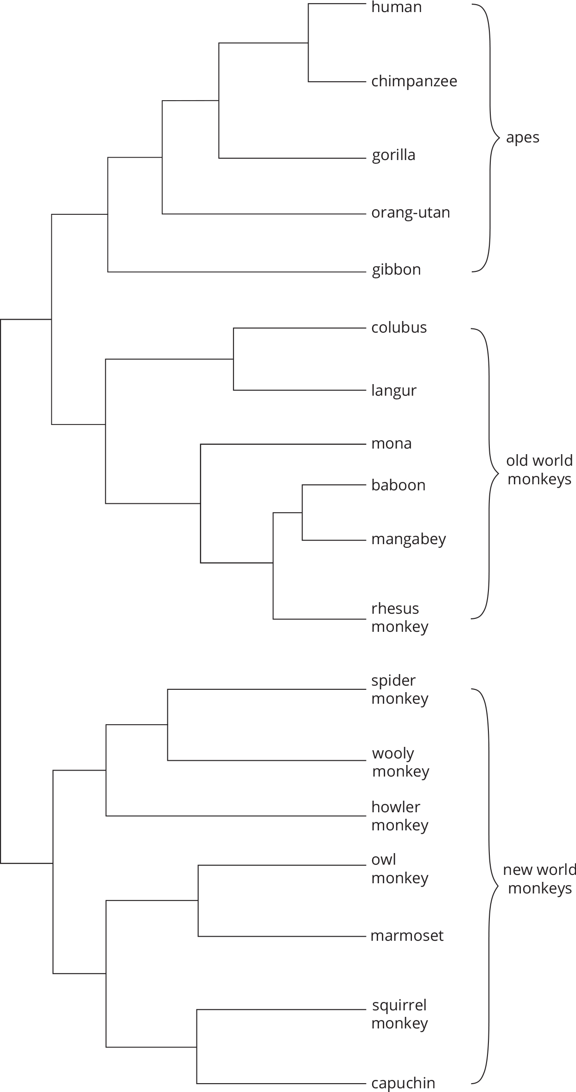

**b** **i** Apes and Old World monkeys form a paraphyletic group. Identify the position of the required common ancestor, by circling it on the phylogenetic tree. 1 mark

1. The howler monkey also has trichromatic vision. What sort of evolution has resulted in colour vision in these monkeys? Explain. 2 marks

**c** The owl monkeys are nocturnal. They have monochromatic vision. Explain how monochromatic vision could have evolved in the owl monkeys. 3 marks

Question 8 (Total marks 6)

Chromosomal mutations can lead to the formation of oncogenes, and thus to the development of a cancer. Chronic myelogenous leukaemia (CML) is the result of such a mutation. The mutation involves chromosomes 9 and 22, as shown in the diagram below. The chromosomes on the left are the normal chromosomes and those on the right are mutated.

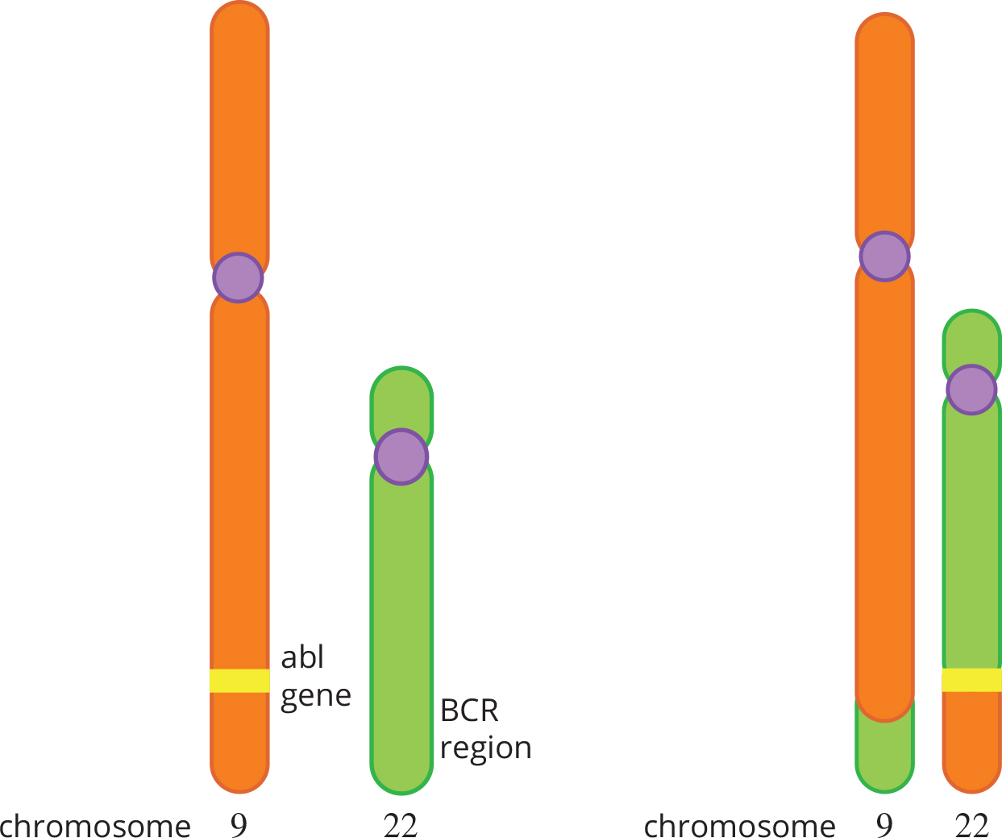

**a** What is the name given to this type of mutation? 1 mark

The fusion of *abl* and *BCR* creates a very long gene, which results in the formation of a large abnormal protein. This protein is an enzyme in a signal cascade that causes white blood stem cells in the bone marrow to divide. The mutated protein causes the cells to divide in an uncontrolled manner, resulting in the production of large numbers of immature, non-functional granulocytes.

**b** One symptom of CML is enlarged lymph nodes. Explain why. 2 marks

**c** **i** Traditional treatment for CML had only a limited effect, with less than 20% of people diagnosed with the condition surviving for 7 years from diagnosis. The high mortality rate and the fact that the cause is a single mutated protein made CML a likely target for a drug created using rational drug design. The drug that was designed is now marketed under the name Gleevec® (or Glivec® in some countries). Using Gleevec® as an example, describe how such a drug is created. 2 marks

1. When drugs move to human trials, the testing is usually done with a double-blind study. Patients are divided into two groups: one group receives the drug and the other receives a placebo. In the test, neither the patients nor the doctors who deal with them know who is receiving the drug. A separate group of researchers evaluate the results. In the initial trial of Gleevec®, 54 patients received the drug and a similar number would have been given the placebo. The recommended treatment period with Gleevec® is a year. After one month of treatment, 53 of the 54 patients had gone into complete remission, and had almost no side effects. This result created an ethical problem for the researchers. Explain why. 1 mark

End of Examination